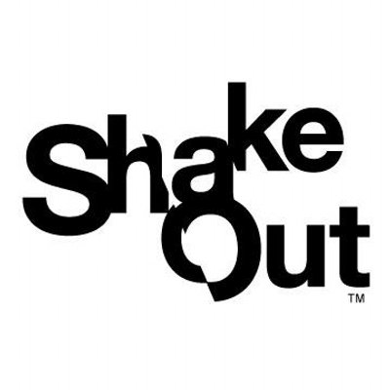
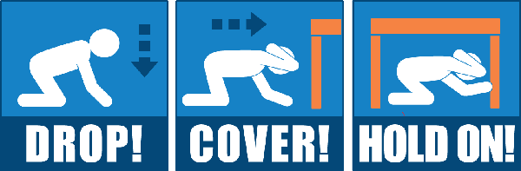

My guess is that every Disciples congregation in the PSWR has practiced an Earthquake Drill at least once. Great ShakeOut Earthquake drills began in California in 2008 and are now global! This year 55,990,207 participants registered, but if you missed this opportunity remember it is never too late practice or update your plans. If you have any questions or need some suggestions send me an email.
The Great ShakeOut is a great opportunity to continually improve your earthquake plans by assisting members of your congregation in making their personal plans and building their survival kits. As you check your congregational plans insure your plans include support for members with disabilities and other access or functional needs. (http://www.earthquakecountry.org/library/ShakeOut_Earthquake_Guide_Disabilities_AFN.pdf)
Rev. Dr. Norman L. Williams
PSWR Disaster Recovery Ministry
ChNorm@msn.com

